SEAMOON ONE TIME PASSWORD SDKs
How to use description

1、Need in the database, create a table to save OTP Token SN information, SN information is in the following format:
Token SN information table
SN(serial number) | SN informaion
795001234 | SS…………………………….
795001235 | SS……………………………
795001236 | SS……………………………
Note: each batch of OTP Token will be matched by the SN files (such as file: SNv7.smd), the file is a text file, the file format is one line one token, each line format is "SN,SN information" . Between SN and SN information ,separated by commas. Need to provide the function importing the file into the SN information table.

2、In the user table, need to increase the two fields,
one field for the authentication type options, such as：
- 1：”Static passwords + dynamic password” Authentication
- 2：”dynamic password” Authentication
- 3：”Static passwords” Authentication
- 4：”Windows Domain” Authentication
Another field is about the user login account and the OTP token SN binding relation. Such as：
User table
User Login Account | User Name | Department | position | …….. | authentication type options | OTP Token serial number
LoginName1 | Clinton | Ministry of Information | Manager | … | Static passwords + dynamic password | 795001234
LoginName2 | Bush | R&D Department | Engineer | … | Static passwords + dynamic password | 795001235
LoginName3 | Obama | Sales Department | Charge | … | Static passwords + dynamic password | 795001236
Note: Need to provide the function to bind or unbind between the user Login account and the OTP token SN(token serial number).

3、Recommend the use of "static password + dynamic password" authentication method
- static password：The application software original password；
- dynamic password：That obtaining from the OTP token. 6 digits or 8 digits (The token that SN number starting from 7 is 6 digits dynamic password, the others is 8 digits dynamic password)；

When the authentication method is "static password + dynamic password", user enter the password in the same one inside box: first enter the static password, following the dynamic password;
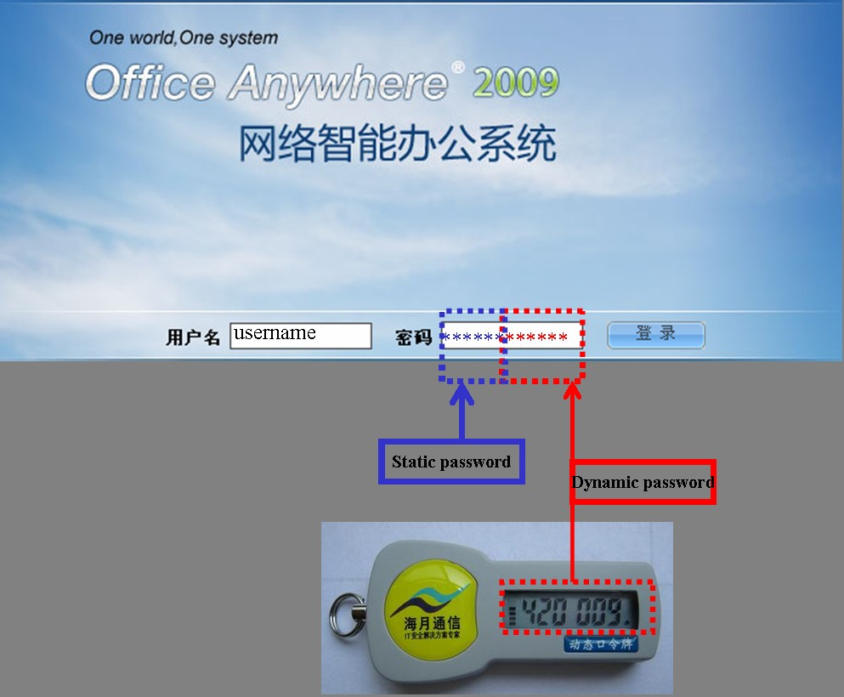

Dynamic password length is fixed at 6 or 8, when the SN is beginning from 7(for example, 795001234), the dynamic password length is 6, the others SN beginning the dynamic password length is 8.
In this way, when the user login, you need to divide the password of the user entering into two parts, the last 6 or 8 is a dynamic passwords, others are static password. First to determine whether the part of a static password is correct, and then to determine whether the part of dynamic password correct? Both correct, then authentication pass.

4、Interface for MS windows
4.1 Interface No.1: Dynamic Password Authentication Interface
API declaration：String CheckITSecurityPassWord(String SNInfo, String Password)
1）SNInfo：First, get the SN from user table base the user login account, then get the SN information from Token SN information table;
2）Password：the Dynamic Password of the OTP token Showing now；
3）return value：
A）when authentication passed, the return value is the new SN information format on string, at this type the returned string length is more than 3. Special Note: when authentication passed, you should use the return string to replace "SN information table" in the original string.
B）Return value equal to "-2", it said that "dynamic encryption string is wrong"；
3）Return value is equal to "0", it said that "dynamic password error"；

4.2、Interface No.2：The OTP token Time synchronization interface
API declaration：String ITSecurity_SN_syn(String SNInfo, String password,int usestime, String cardclock)
- SNInfo：First, get the SN from user table base the user login account, then get the SN information from Token SN information table；
- Password：the Dynamic Password of the OTP token Showing now;
- Usestime: the OTP token use times. Only use for SecureCard (card-type OTP token), others OTP token fill in 0 is OK;
- cardclock：the OTP token clock. Only use for SecureCard (card-type OTP token), others fill in the string "0" is OK;
- return value：
  - If OTP token Time synchronization success, the return value is the new SN information format on string, at this type the returned string length is greater than 3. Special Note: when Time synchronization success, you should use the return string to replace "SN information table" in the original string.

4.3、Need to register DLL files before use
1）copy the two files: SeaMoonDLL.dll ，ITSecurity.dll to the System32 Folder.
2）use [regsvr32] command register the DLL file:
regsvr32 c:\windows\system32\seamoondll.dll
3）Please refer to examples [aspdemo] and [netdemo]。

5、Interface for for java
5.1、Interface No.1: Dynamic Password Authentication Interface
API declaration： String checkpassword(sninfo, password)
1）SNInfo：First, get the SN from user table base the user login account, then get the SN information from Token SN information table;
2）Password：the Dynamic Password of the OTP token Showing now；
3)return value：
when authentication passed, the return value is the new SN information format on string, at this type the returned string length is more than 3. Special Note: when authentication passed, you should use the return string to replace "SN information table" in the original string.
B）Return value equal to "-2", it said that "dynamic encryption string is wrong"；
3）Return value is equal to "0", it said that "dynamic password error"；
5.2、Interface No.2：The OTP token Time synchronization interface
API declaration：String passwordsyn(sninfo, password)
- SNInfo：First, get the SN from user table base the user login account, then get the SN information from Token SN information table；
- Password：the Dynamic Password of the OTP token Showing now;
- return value：
when authentication passed, the return value is the new SN information format on string, at this type the returned string length is more than 3. Special Note: when authentication passed, you should use the return string to replace "SN information table" in the original string.
B）Return value equal to "-2", it said that "dynamic encryption string is wrong"；
3）Return value is equal to "0", it said that "dynamic password error"；

6、Interface for for php
6.1、Interface No.1: Dynamic Password Authentication Interface
API declaration： String checkpassword(sninfo, password)
1）SNInfo：First, get the SN from user table base the user login account, then get the SN information from Token SN information table;
2）Password：the Dynamic Password of the OTP token Showing now；
3)return value：
when authentication passed, the return value is the new SN information format on string, at this type the returned string length is more than 3. Special Note: when authentication passed, you should use the return string to replace "SN information table" in the original string.
B）Return value equal to "-2", it said that "dynamic encryption string is wrong"；
3）Return value is equal to "0", it said that "dynamic password error"；
6.2、Interface No.2：The OTP token Time synchronization interface
API declaration：String passwordsyn(sninfo, password)
- SNInfo：First, get the SN from user table base the user login account, then get the SN information from Token SN information table；
- Password：the Dynamic Password of the OTP token Showing now;
- return value：
when authentication passed, the return value is the new SN information format on string, at this type the returned string length is more than 3. Special Note: when authentication passed, you should use the return string to replace "SN information table" in the original string.
B）Return value equal to "-2", it said that "dynamic encryption string is wrong"；
3）Return value is equal to "0", it said that "dynamic password error"；

7、Interface for linux(call directly mode, for C,C++)
7.1、Interface No.1: Dynamic Password Authentication Interface
API declaration： int ITSecurity_password_check(char *pInitCB,
char *pPassword,
char *pResultCB,
int iResultCBSize);
1）pInitCB：pInitCB is SNInfo. First, get the SN from user table base the user login account, then get the SN information from Token SN information table;
2）Password：the Dynamic Password of the OTP token Showing now；
3）pResultCB：the SNInfo return, when authentication passed, the return value is the new SN information format on string.
Special Note: when authentication passed, you should use this string to replace "SN information table" in the original string.
4) iResultCBSize: the size of pResultCB, should be more than 1000 bytes.
5)return value
Return value
200 | Authentication pass
300 | Authentication fail
-1 | Authentication fail,for the SNinfo is error
-2 | Authentication fail, parameter error
-3 | Authentication fail ,DLL or so file error
7.2、Interface No.2：The OTP token Time synchronization interface
API declaration：int ITSecurity_password_syn(char *pInitCB,
char * Password,
int Usestime,
char * cardclock,
char *pResultCB,
int iResultCBSize )

1)pInitCB：the same as SNInfo.First, get the SN from user table base the user login account, then get the SN information from Token SN information table；
2)Password：the Dynamic Password of the OTP token Showing now;
3)Usestime: the OTP token use times. Only use for SecureCard (card-type OTP token), others OTP token fill in 0 is OK;
4)cardclock：the OTP token clock. Only use for SecureCard (card-type OTP token), others fill in the string "0" is OK;
5)pResultCB：the SNInfo return, when authentication passed, the return value is the new SN information format on string.
Special Note: when authentication passed, you should use this string to replace "SN information table" in the original string.
6) iResultCBSize: the size of pResultCB, should be more than 1000 bytes.

7)return value：
Return value
200 | Time synchronization succeed
300 | Time synchronization fail
-1 | Time synchronization fail,for the SNinfo is error
-2 | Time synchronization fail, parameter error
-3 | Time synchronization fail ,DLL or so file error
-4 | Time synchronization fail,others error

Question on line:
Li Peiji
e-Mail: lipeiji@seamoon.com.cn
MSN: lipeiji2008@hotmail.com
Skype: lipeiji7000
TEL : 0086-755-83660075
Mobile :0086-13751150099
Website : http://www.seamoon.com.cn/index-english.asp

